Compile Code

Make sure to read to compile code.

Files without .o file.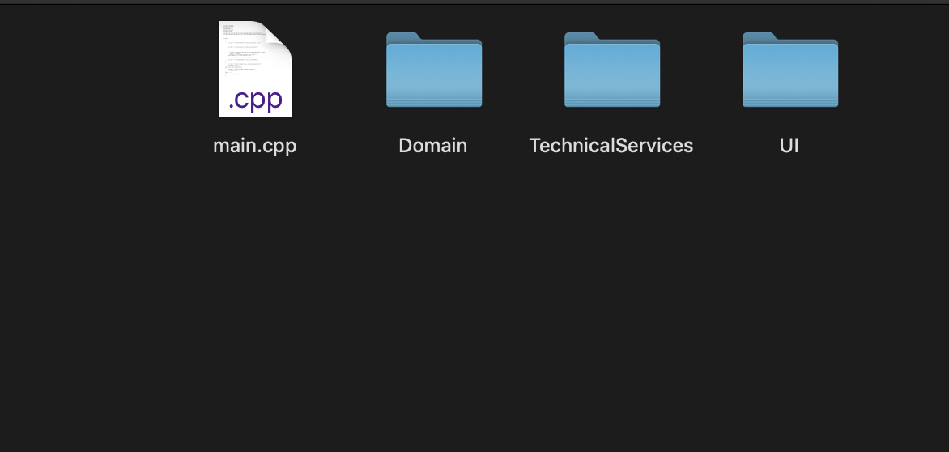

All #include's of .hpps have to match where you have placed the files in your computer.

Example: #include "/Users/hecthor/Desktop/fall_2019/462/sampleCode/TechnicalServices/Persistence/SimpleDB.hpp"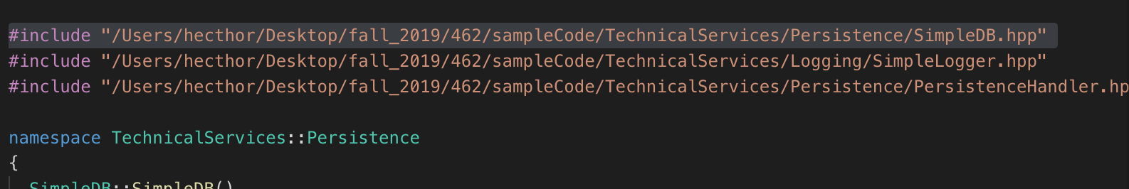

Make sure to compile every .cpp file separately creating .o files.

Example: g++ -std=c++17 -c main.cpp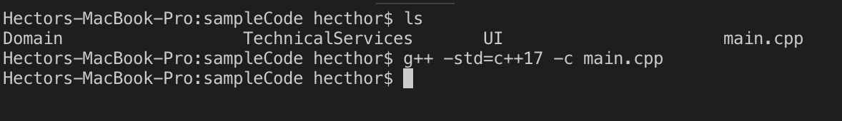

It should create a .o file inside your file. Make sure to do this to every .cpp file inside the sample code.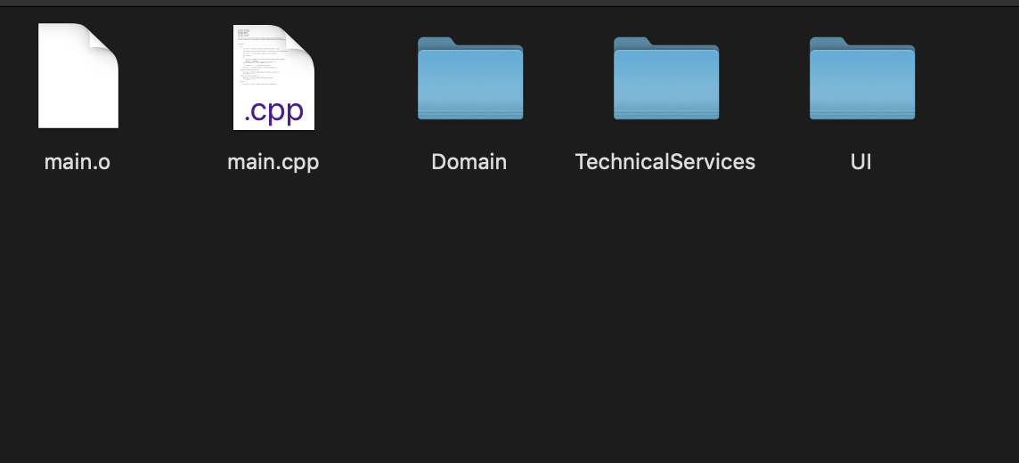

Another example creating the .o file inside /Domain/AccountManagement file, creating the .o file for UserAccounts.cpp.

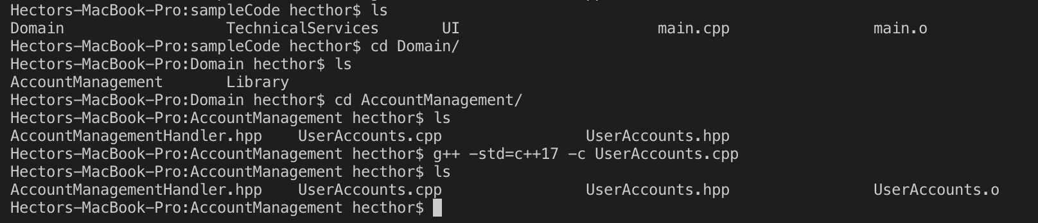

Once all .o files have been created, compile all .o files into an executable file. Include the path if some .o files are not at the root.

Example:g++ main.o UI/SimpleUI.o TechnicalServices/Persistence/SimpleDB.o Domain/AccountManagement/UserAccounts.o Domain/Library/Session.o -o main



Should create an .exec file inside the root file.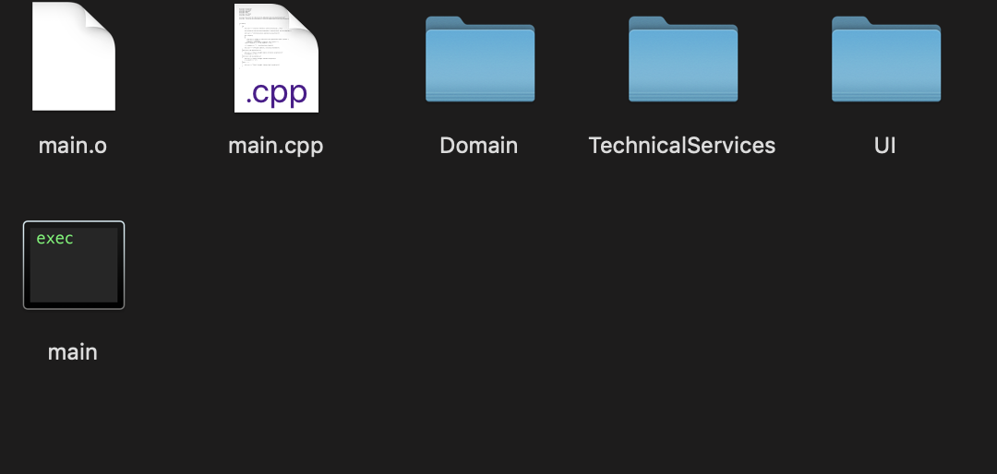

Then just run ./main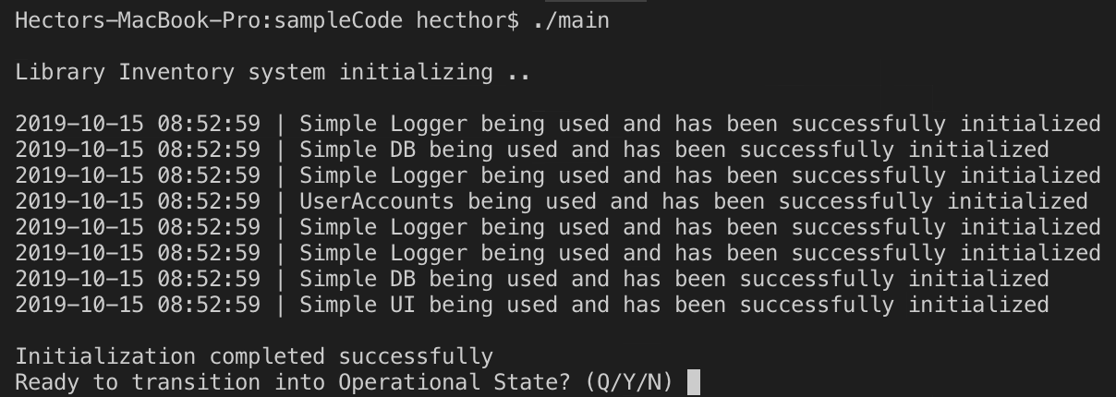

Sample run: Denied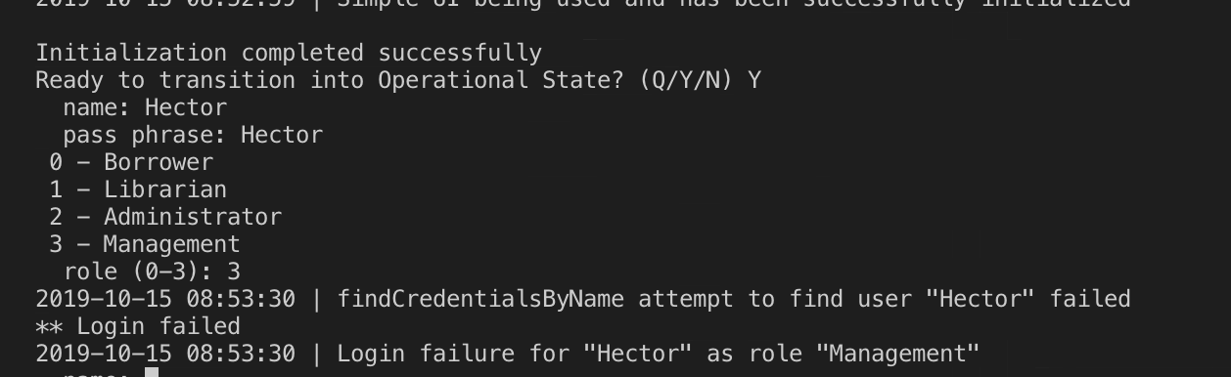

To gain access change the SimpleDB.cpp or use any of the stored users to gain access.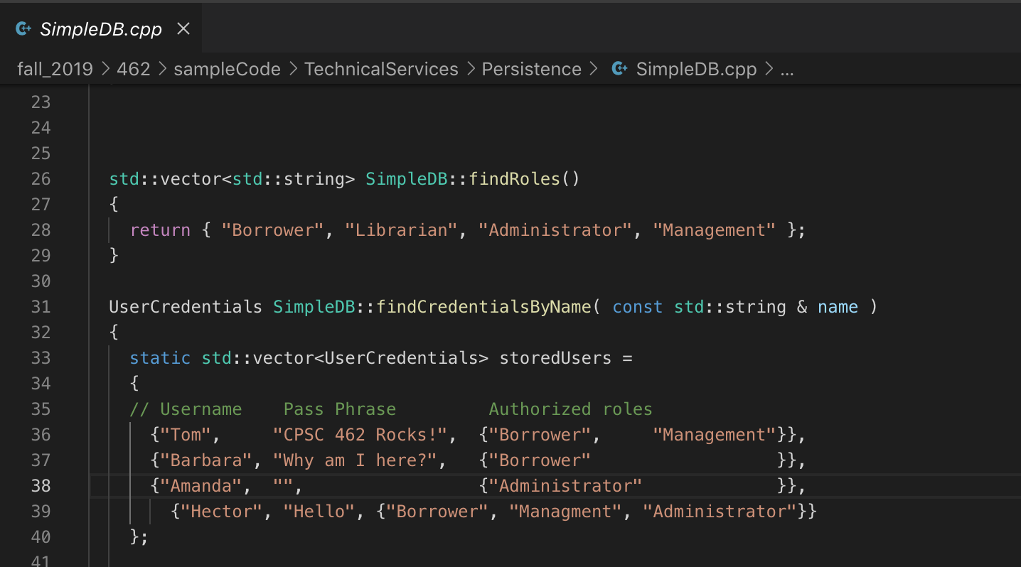

We are in!

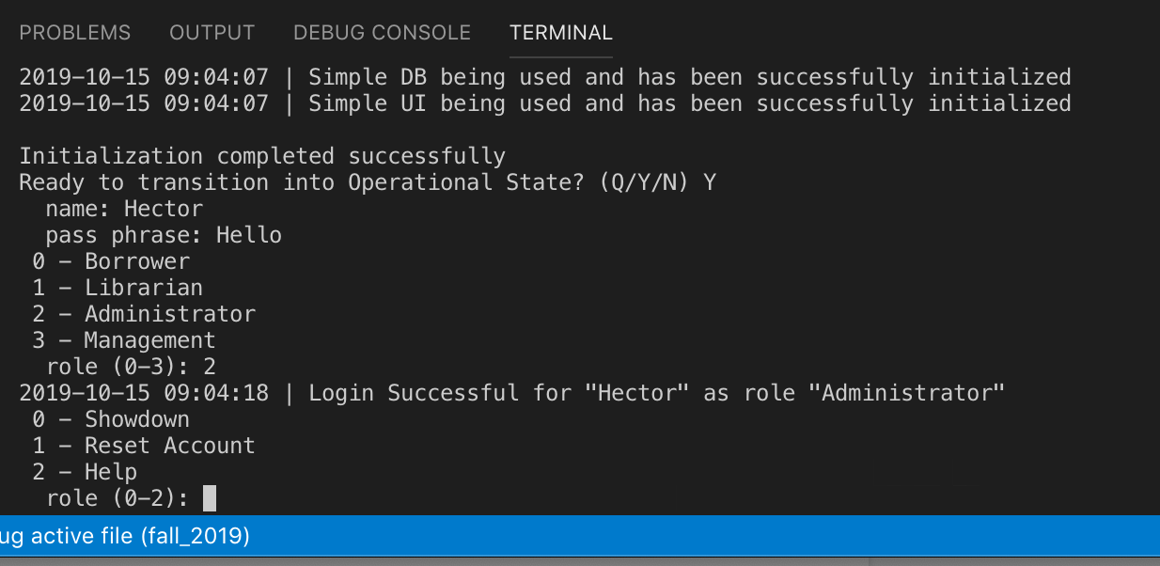

If you have any questions, I will gladly help on wednesday. I included the .o files in the github, check if you can just run the .exe file without doing it yourself. Make sure to change the #include’s to your computer’s path where you have placed the code.